Coming Home:
Recovery, Treatment, & Funding Strategies for Successful Reintegration of Formerly Incarcerated Persons Who Have a Serious Mental Illness

Presentation to the California State Senate Select Committee on Mental Health

Ross Peterson, Vice President, National Marketing/Government Relations

Telecare Corporation
May 31, 2013

Introduction
Almost 20% of those currently serving time in California state prisons have a mental illness, most also have serious substance abuse issues. Using a cohesive approach to treatment when these offenders return to our community can break the cycle of making poor choices, reoffending and re-incarceration. The outcomes demonstrated by programs such as the Mentally Ill Offenders Crime Reduction Grant Awards (MIOGRA), AB34/2034, and most recently the Integrated Services for Mentally Parolees (ISMIP) provide us with a map of the road to success.
Using Evidence Based Practice such as California’s version of Assertive Community Treatment (ACT), Full Service Partnerships, with access to housing, psychiatric treatment, smaller specialized parolee agent case loads and starting medications and applications for benefits while offenders are still in prisons are part of this formula for success. With the expanded eligibility for Medi-Cal offer Affordable Health Care and allowing parolees’ access to Specialty Mental Health Medi-Cal we can use federal dollars to fund a major component of the cost of these programs. The Senate President Pro Tem’s proposal to expand ISMIP to 5,000 parolees can provide the frame work for this system transformation and ultimately create a safer more humane environment for the Citizens of California. As a major provider of mental health services we have seen the proof of what is in our reach of possibilities.

About Telecare Corporation
Telecare specializes in services and supports for consumers with serious mental illness and complex needs. We have more than 70 programs and 2,500 employees in California, Nebraska, North Carolina, Oregon, Pennsylvania, New Mexico, Texas and Washington. Our spectrum of services includes: Inpatient Acute; Inpatient Non-Acute; 23-Hour Crisis Stabilization; Residential (Crisis, Transitional); Full Service Partnerships; Case Management; and Prevention/Early Intervention. We also provide specialized services to individuals who face challenges in addition to their mental illness, including those who have current or histories of co-occurring substance use disorders, developmental disabilities, criminal justice involvement, homelessness, and physical health challenges.

Telecare’s Forensic Mental Health Services
Telecare has extensive experience serving consumers with serious mental illness and histories of criminal justice involvement through its AB34/2034, Secure Residential Treatment, Forensic Assertive Community Treatment (FACT), Integrated Services for Mentally Ill Parolees (ISMIP), and AB109 programs.

Implemented in 1999 to 2001, our AB34 and AB2034 model programs emphasized 24/7 availability, multi-disciplinary teams, and a comprehensive harm reduction approach to helping homeless clients with severe mental illness—including many with histories of incarceration—to obtain and maintain housing. Telecare operated seven AB2034 programs in California prior to the elimination of the AB2034 program. Four of these programs still operate today as ACT/FSP programs funded by the Mental Health Services Act (MHSA).

Telecare provides two secure residential treatment programs in Oregon, established in 2006 and 2010. The Recovery Center at Woodburn is a secure residential treatment facility serving consumers under the jurisdiction of the Oregon Psychiatric Security Review Board (PSRB). The Recovery Center at Woodburn has provided the state with significant savings by delivering services and supports in a setting that is more therapeutic and less costly than the state hospital. A second secure residential facility serves eight PSRB clients and eight civilly committed clients in Bend, Oregon.

Our first FACT program was established in 2008 in San Bernardino County, and we have since added three more FACT programs providing ACT/FSP services specifically tailored for consumers with serious mental illness and histories of criminal justice involvement. These programs frequently work in partnership with mental health courts or special probation caseloads, and/or include a probation officer on the multidisciplinary team. Serving a total of 195 consumers, our FACT programs reduce the frequency and length of acute psychiatric hospital admissions; improve individuals’ ability to function in the community; and reduce the frequency and length of incarcerations. The following chart demonstrates significant pre/post enrollment reductions in psychiatric hospital utilization, re-incarcerations and homelessness experienced by participants of the San Bernardino FACT program.

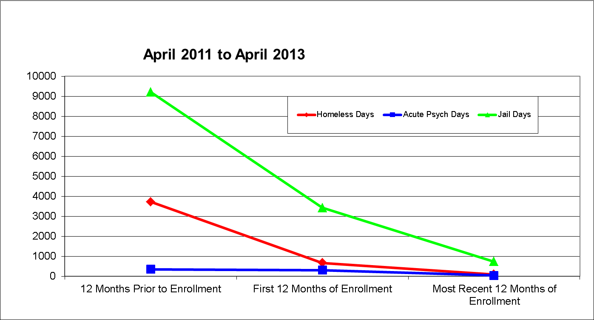

In 2011, the County and San Bernardino FACT were given a National Association of Counties Achievement Award for innovation in new programs.

In 2009, Telecare partnered with the California Department of Corrections and Rehabilitation (CDCR) to implement the Integrated Services for Mentally Ill Parolees (ISMIP) program in San Diego, San Bernardino, and Los Angeles Counties in order to address the problem of high recidivism rates among parolees with serious mental illness. Telecare named these programs Corrections Outreach Recovery Enhancement (CORE). Key features of the CORE include:

- Multidisciplinary Team (ACT) approach
- Integrated services
- Low client-staff ratios
- Locus of contact in the community
- Medication management (Medi-Cal)
- Focus on everyday issues and problems in community reintegration

These programs serve 200 consumers. Pre- and post-enrollment client data demonstrate significant reductions in re-incarcerations, and homelessness. The following charts capture client outcome data in the CORE-L.A. 1 program.

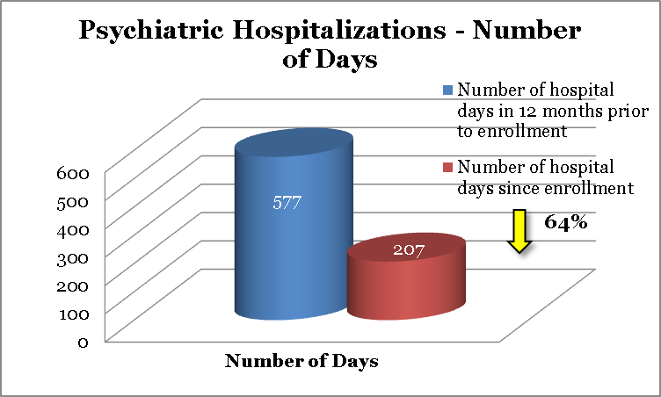
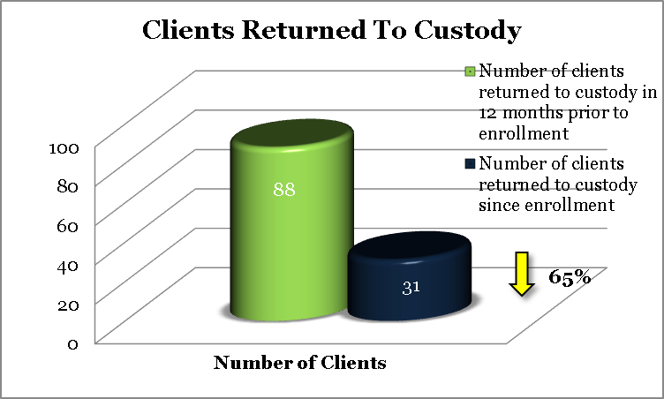
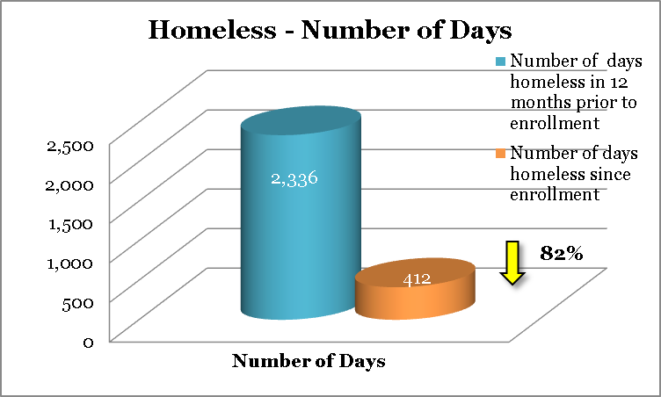
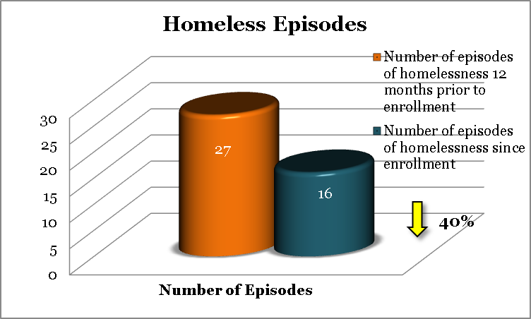

In 2011, Telecare partnered with four counties to provide mental health services to persons with serious mental illness under AB109 (Public Safety Realignment) Post Release Community Supervision. Telecare currently provides five AB109 programs serving over 250 consumers using ACT-level services, or using a structured psycho-educational approach coupled with cognitive behavioral therapy.

Recovery-Centered Mental Health Services and Criminogenic Needs
The criminal justice system and mental health service providers share the common goal of creating safer communities. For offenders with mental illness, reducing re-offense goes beyond providing clinical services to alleviate psychiatric symptoms – it also means addressing the specific risk factors that increase the likelihood of recidivism. These risk factors – antisocial values/attitudes/peers, problematic family circumstances, impulsive behavior, among others – have been shown to predict recidivism regardless of mental health status. In recent years the field of community justice has produced several evidence-based models that use cognitive behavioral interventions to address these “criminogenic needs.”

At Telecare, we continue to refine our approach to forensic mental health services by reviewing our experiences in the field and securing additional expertise and training to ensure our programs reflect a combined emphasis on recovery-centered mental health treatment and community justice evidence-based practices shown to address criminogenic needs and reduce recidivism.

ISMIP Challenges and Lessons Learned
- Identifying eligible parolee
- Medi-Cal and SSI benefits
- Housing Options / Homelessness
- Access to Health Care
- Access to Medications
- Need for pre-employment and vocational services
- High levels of co-occurring substance abuse

- Lack of access to Specialty Mental Health Funding
Recommendations
- Allow CDCR to contract with CalMHSA as a Specialty Mental Health Provider for ISMIP services or via the Counties
- It is estimated 30% -40% current cost of services for Medi-Cal eligible consumers could be funded via FFP
- With proposed expansion of ISMIP from its current 400 to 5,000 members combined with expanded Medi-Cal eligibility under the Affordable Care Act could result in saving millions of State General Fund dollars each year.

- Allow smaller specialized parolee caseloads for consumers with serious mental illness.
Research supports the need for collaboration between those providing supervision and those providing mental health treatment. Such partnerships can include specialized caseloads, problem-solving case conferences, cross-training opportunities, and active participation by parole officers on mental health treatment teams. In models such as Mental Health Court and Forensic Assertive Community Treatment (FACT), the legal system works closely together with treatment professionals while also leveraging other resources important to successful re-entry (housing, vocational services, benefits assistance) using a strong case management orientation.

- Begin the benefit application process as soon as allowable while persons are still in Prison.

- Where “injectables” are clinically indicated begin process while still in Prison.

- Promote Evidence-Based Practices and Programs
- Assertive Community Treatment
- Integrated Mental Health and Substance Abuse
- Supported Employment
- Supported Housing
- Cognitive Behavioral Treatment

Council of State Governments Justice Center, “Improving Outcomes for People With Mental Illness Under Community Corrections Supervision: A Guide to Research-Informed Policy and Practice,” (New York, 2009).
Alex M. Blandford, MPH, and Fred C. Osher, MD (2012). “A Checklist for Implementing Evidence-Based Practices and Programs for Justice-Involved Adults with Behavioral Health Disorders. Delmar, NY: SAMHSA’s GAINS Center for Behavioral Health and Justice Transformation.

